**CANDIDATES NAME:…………………………………………………………………**

|  |  |  |  |  |  |  |  |
| --- | --- | --- | --- | --- | --- | --- | --- |
| **INDEX NUMBER** | | | | | | | |
|  |  |  |  |  |  |  |  |

**SIGNATURE: ……………………………………**

**273/1**

**GEOGRAPHY**

**PAPER 1**

**JUNE/JULY**

**2 HOURS 30 MINUTES**

**MOCK EXAMINATIONS SET 1 2019**

**Uganda Certificate of Education**

**GEOGRAPHY**

**PAPER 1**

2 HOURS 30 MINUTES

**INSTRUCTIONS TO CANDIDATE:**

* *This paper consists of part I and II.*
* *Part I and section A of part II are compulsory.*
* *Answer only one questions from section B of part II.*
* *Answers to all questions must be written in the answer booklet provided.*
* *Any additional question(s) answered will not be marked.*

**PART I:**

**OBJECTIVE TYPE QUESTIONS (30 MARKS)**

**(These are 30 compulsory questions. Each question carries one mark. Answers to this part must be written in the answer booklet provided)**

1. Nyanza province in Kenya is densely populated mainly due to

A. reliable rainfall B. adequate social services

C. employment opportunities D. improved security

2. The major problem affecting tourism in Kidepo valley national p ark is

A. competition B. insecurity

C. poaching D. limited accommodation

3. Chemical weathering processes in East Africa are mainly due to

A. rock age B. rock type

C. abundant water D. relief of the area

4. Inselbergs in East Africa are formed due to exposure of

A. dyke B. sill C. batholith D. laccolith

5. The main reason for containerisation in Mombasa port is to

A. speed up loading and offloading goods

B. reduce theft of commodities

C. reduce damage of goods

D. avoid costly packing materials

6. Which one of the following lakes in East Africa was formed due to river damming?

A. Manyara B. Kyoga C. Bunyonyi D. Ngozi

7. Which one of the following plant species grows in cold areas of East Africa?

A. Ebony B. Lobelia C. Scrub D. acacia

8. The common type of fish reared on fish farms in East Africa is

A. Tilapia B. Marlin C. Bagrus D. Capenta

9. Which one of the following is a secondary industry in East Africa?

A. oil refinery B. salt extraction

C. boat building D. tourism

10. Which one of the following statements correctly describes soil texture?

A. different sizes of soil particles

B. the way soil particles are held together

C. horizontal arrangement of soils along a slope

D. vertical arrangement of soils along a slope

11. Diamond at Mwadui in Tanzania is mined by use of

A. adits B. shafts

C. mechanical dredgers D. open cast

12. The high rate of forest destruction in Uganda is mainly due to

A. pests and diseases B. crop cultivation

C. human settlement D. forest fires

13. The major problem faced by nomadic pastoralists in East Africa is

A. over grazing B. cattle rusting

C. prolonged drought D. easy spread of diseases

14. Which one of the following fish landing sites is found on Lake Kyoga?

A. Kigoma B. Lale C. Magu D. Katunguru

15. Which one of the following features is found in the mature stage of a river?

A. waterfalls and rapids B. interlocking spurs

C. deltas D. gorges

16. The high population growth rate in Uganda is mainly caused by

A. high birth rates B. imbalances sex ratio

C. limited family planning D. cultural beliefs

17. Clay soils in East Africa have developed due to

A. accumulation of organic matter B. maximum leaching

C. maximum deposition D. impended drainage

18. Lake Nabugabo in Uganda was formed as a result of

A. warping B. vulcanicity

C. long shore drift D. erosion

19. Which one of the following areas in East Africa experiences a single rainfall peak?

A. Mombasa B. Kisumu C. Entebbe D. Bukoba

20. Which one of the following is the major commercial product from the Kongwa scheme in Tanzania?

A. meat B. milk C. hides D. skins

21. Dar – es – Salaam has developed into a major industrial centre in Tanzania mainly due to its

A. Coastal location B. large hinterland

C. large population D. oil refining activity

22. Which one of the following escarpments is found on the Eastern rift valley of East Africa?

A. Butiaba B. Mau C. Chunya D. Kichwamba

23. Which of the following areas in Tanzania is famous for pyrethrum growing?

A. Bukoba B. Mbeya C. Dodoma D. Songea

24. Which one of the following is a tributary of river Rufigi?

A. Galana B. Nzoia C. Great Ruaha D. Pangani

25. Cement production along the coastal areas of East Africa mainly dependent on the presence of

A. constant water supply B. coral reefs

C. gentle relief D. skilled labour

26. Aspect is of little significance in determining East Africa’s climate because

A. the sun is always over head in East Africa

B. East Africa is mainly a plateau land

C. East Africa is in high latitudes

D. East Africa has high mountains

27. Granite rocks are formed due to

A. heat and pressure B. extrusion of magma

C. sediment deposition D. intrusion of magma

28. Which one of the following is the main cause of rural – urban movements in East Africa?

A. land shortage B. unemployment

C. natural calamities D. insecurity

29. The wearing down of rock particles as they collide with each other is called?

A. solution B. attrition C. abrasion D. hydraulic

30. River Tana in Kenya is important to the people mainly because it

A. aids hydroelectric generation

B. provides water for generation

C. provides water for domestic and industrial use

D. enables water transport

**PART II**

**MAP WORK, PHOTOGRAPH INTERPRETATION, FIELD WORK AND EAST AFRICA.**

**SECTION A:**

1. Compulsory question: **MAP WORK** (20 marks)

Answer all parts of this question.

a) i) State the grid reference of the air photo principal point with sortie No. 047. (1 mark)

ii) Identify the feature found at grid reference 093410. (1 mark)

b) Determine the:

i) area covered by Lake Kyoga north of northing 50. (2 marks)

ii) distance (in kilometres) of the sub country boundary between grid references 000424 and 061559. (2 marks)

c) Draw a cross section of the area shown between grid references 069472 and 112420 and on it mark and name:

i) transport routes

ii) settlement

iii) any one vegetation type

iv) raised land (7 marks)

d) Describe the

i) relief (3 marks)

ii) relationship between relief and drainage of the area shown.

(4 marks)

2. Compulsory question: **PHOTOGRAPH INTERPRETATION** (15 marks)

Answer all parts of this question.

Study the photograph provided below and answer the questions that follow.

2.

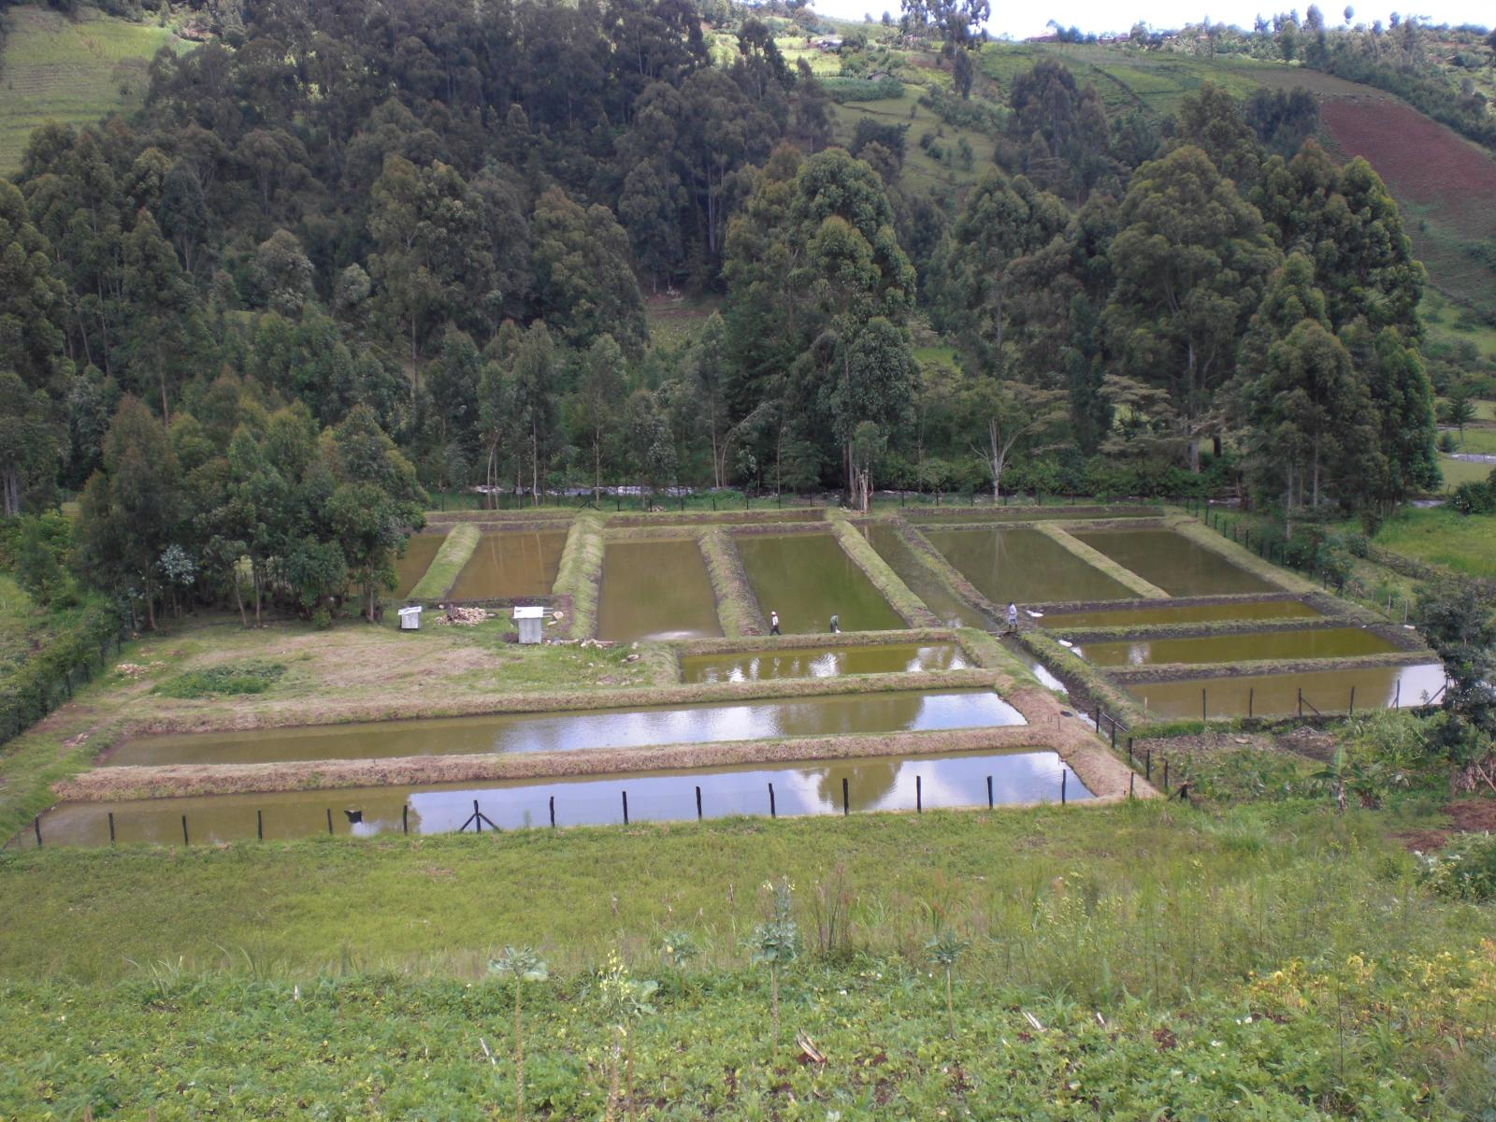

a) Draw a land scape sketch of the photograph shown above and on it mark and name:

i) Any two vegetation types

ii) any two relief features

iii) fish ponds (6 marks)

b) Describe the relationship between relief and land use in the area shown on the photograph. (4 marks)

c) Giving evidence, explain the problems limiting land use in the area shown on the photograph. (4 marks)

d) Giving reasons for your answer, suggest one area in East Africa where the above photograph could have been taken. (1 mark)

3. COMPULSORY **FIELDWORK** QUESTION (15 marks)

Answer all parts of this question.

For any one field work study you have conducted either as a group or an individual;

a) State the:

i) topic (2 marks)

ii) objectives (3 marks)

of the study.

b) Explain any two methods used to collect data during the study. (4 marks)

c) Describe the relationship between physical features and land use in the area studied. (4 marks)

d) Outline the problems faced during the study. (2 marks)

**SECTION B:**

**EAST AFRICA (20 marks)**

Answer only one question from this section.

4. a) i) Distinguish between Rill erosion and Gulley erosion. (4 marks)

ii) Identify any two areas in East Africa most affected by gulley erosion. (2 marks)

b) Describe the conditions leading to the occurrence of gulley erosion in the area identified in a (ii) above. (5 marks)

c) Explain the effects of soil erosion in East Africa. (6 marks)

d) Outline the steps being taken to control soil erosion in East Africa.

(3 marks)

5. a) Draw a sketch map of East Africa and on it mark and name:

i) National parks: Serengeti and Murchison falls

ii) Game reserves: Masai-Mara and Selous

iii) River Nile. (6 marks)

b) Describe the factors favouring wild life conservation in East Africa.

(5 marks)

c) Explain the importance of wild life conservation to the development of East Africa. (6 marks)

d) Outline the problems threatening wild life conservation in East Africa.

(2 marks)

6. Study the map of Kenya provided below and answer the questions that follow.

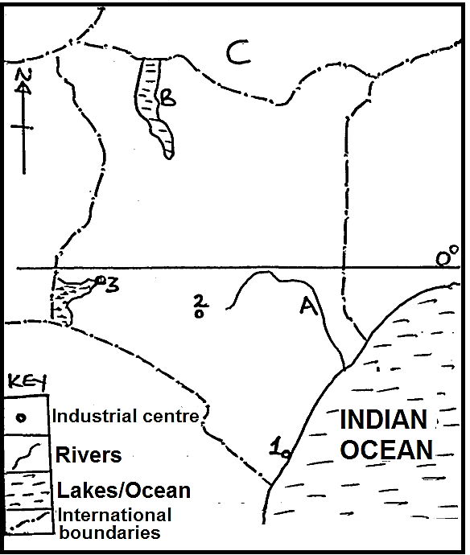

a) Name the:

i) Industrial towns marked 1, 2 and 3.

ii) Water body marked A and B.

iii) Neighbouring country marked C. (6 marks)

b) Describe the conditions that have favoured industrial development in any one industrial centre named in a(i) above. (5 marks)

c) Explain the effects of industries on the environment in Kenya. (6 marks)

d) Outline any three industrial products produced in Kenya. (3 marks)

7. Study the table below showing population size for selected census years in Uganda and answer the questions that follow.

|  |  |
| --- | --- |
| Census year | Population size (‘000) |
| 1969  1980  1991  2012  2014 | 9,535  12,636  16,671  24,227  34,856 |

a) Draw a line graph to represent the information contained in the table above. (6 marks)

b) Calculate the percentage change in the population between 1969 – 2014.

(2 marks)

c) Describe the conditions leading to the population trend shown on the table above. (5 marks)

d) Outline the;

i) Problems caused by the population trend between 1969 – 2014 in Uganda. (4 marks)

ii) Steps being taken to overcome the problems in d(i) above.

(3 marks)

**END**